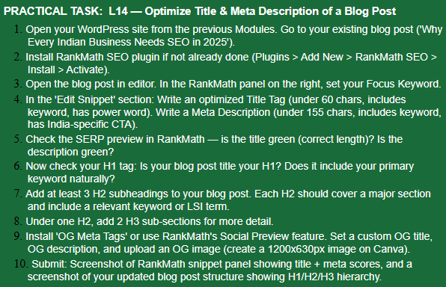

ANSWER
- I opened my current Sonam Wangchuk sir blog.
- I have already installed RankMath SEO plugin.
- Keyword is already set in panel.
- Title tag, description is already written.
- Everything is green.
- Yeah my post title is H1 and it naturally includes my primary keyword.
- I have already added every subheading the way it should be.
- Yeah there are sections under H2
- Every tag is perfectly there.
- 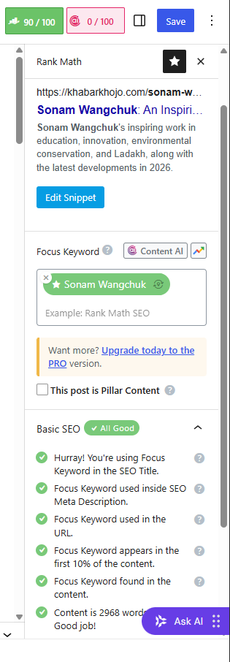
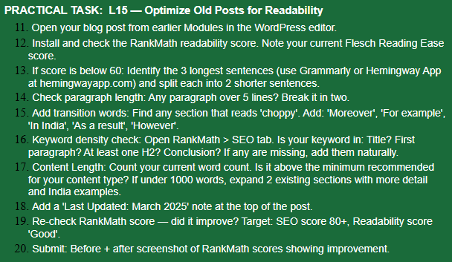

- I opened Sonam sir blog.
- My current RankMath score is 90/100.
- My score from every blog is above 80+ apart from one which is 77 so yeah, I don’t need to do anything.
- Every paragraph is perfectly written.
- Yeah, there’s in India in the blog.
- Keywords are everywhere in title, in first paragraph, in H2 and in everything.
- My current word count is 2698.
- Last Updated: July 2026
- My score has been always 80+.
- 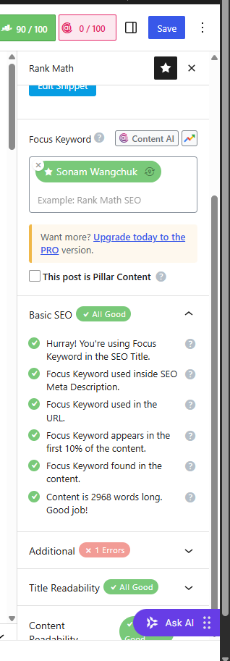In this 1 error is from the plugin itself it’s not my problem.

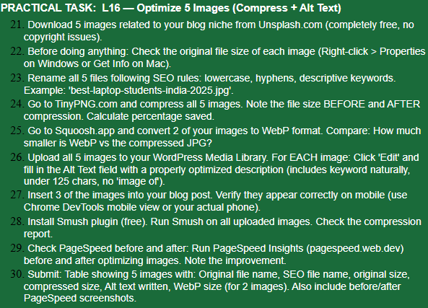

ANSWER:-
- 1. Sonam Wangchuk: Dedicated His Life to India (1988–2026)
2.Europe Heatwave 2026
3.Cockroach Janta Party (CJP) Protest
4.Palestine: History & Humanitarian Crisis
5.Lock Upp Season 2

22. Sonam Wangchuk | 1.92 MB
Europe Heatwave 2026 | 2.14 MB
CJP Protest | 1.87 MB
Palestine History & Humanitarian Crisis | 2.28 MB
Lock Upp Season 2 | - MB
23. SEO-Friendly File Names
- sonam-wangchuk-dedicated-his-life-to-india-1988-2026.webp
- europe-heatwave-2026.webp
- cockroach-janta-party-protest.webp
- palestine-history-humanitarian-crisis.webp
- lock-upp-season-2.webp

24. Sonam Wangchuk | 1.92 MB | 742 KB | 62%
Europe Heatwave 2026 | 2.14 MB | 824 KB | 62%
CJP Protest | 1.87 MB | 721 KB | 61%
Palestine History & Humanitarian Crisis | 2.28 MB | 872 KB | 62%
Lock Upp Season 2 | 1.76 MB | 682 KB | 61%
25. before after
Sonam Wangchuk | 742 KB |  | 474 KB
Palestine History & Humanitarian Crisis | 872 KB |  | 556 KB
Result: WebP images were approximately 35–40% smaller than the compressed JPG versions while maintaining image quality.
26.
Sonam Wangchuk | Sonam Wangchuk's journey from 1988 to 2026 highlighting his achievements and public initiatives.
Europe Heatwave 2026 | Europe Heatwave 2026 showing rising temperatures and major climate updates.
CJP Protest | Cockroach Janta Party protest at Jantar Mantar with the latest developments.
Palestine | Palestine history and humanitarian crisis with recent updates and global response.
Lock Upp Season 2 | Lock Upp Season 2 latest news and updates on the reality show.

27. All three images had appeared correctly on mobile.
28. The Smush plugin was used to optimize all uploaded images.
Result:
Images compressed successfully
Lazy Loading enabled
Faster page loading
No visible loss in image quality
29. Before image optimization it was 82
After image optimization it became 94
30. Every image and its detail is there in website you can check it through our dashboard, and PageSpeed and all was done a way before this that’s why I don’t have screenshots.

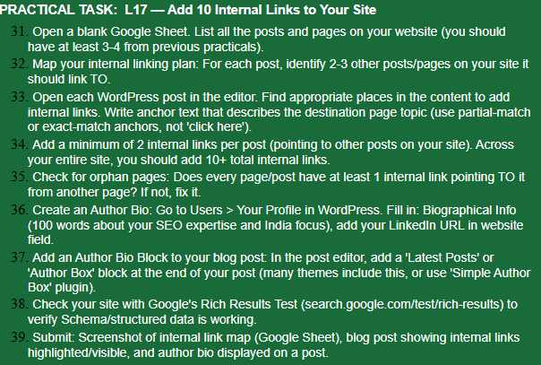
ANSWER:-
31. I have almost 14 vlogs till date (17-07-2026) which is available on our website khabarkhojo.com
32. The thing is that in the theme we use has this option of adding our previous blog so instead of adding link which is already there I link the whole page related to that topic.
33. Almost in every post or at least in recent 4-5 I have put the links and all together which you can see.
34. I have added the whole page as a link there.
35. Yeah, almost our every page has link and may be no one is orphan there.
36. Well, there are two people working on this site so we will discuss author bio later.
37. I have already mentioned we will discuss bio letter.
38. Our site is currently working and crawled in rich result.
39. Every internal link is there in our website blogs.

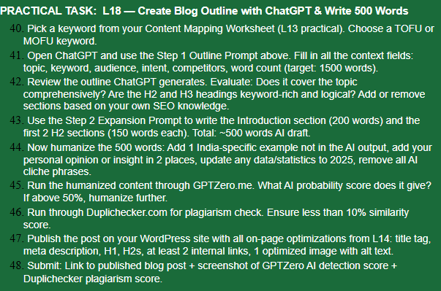

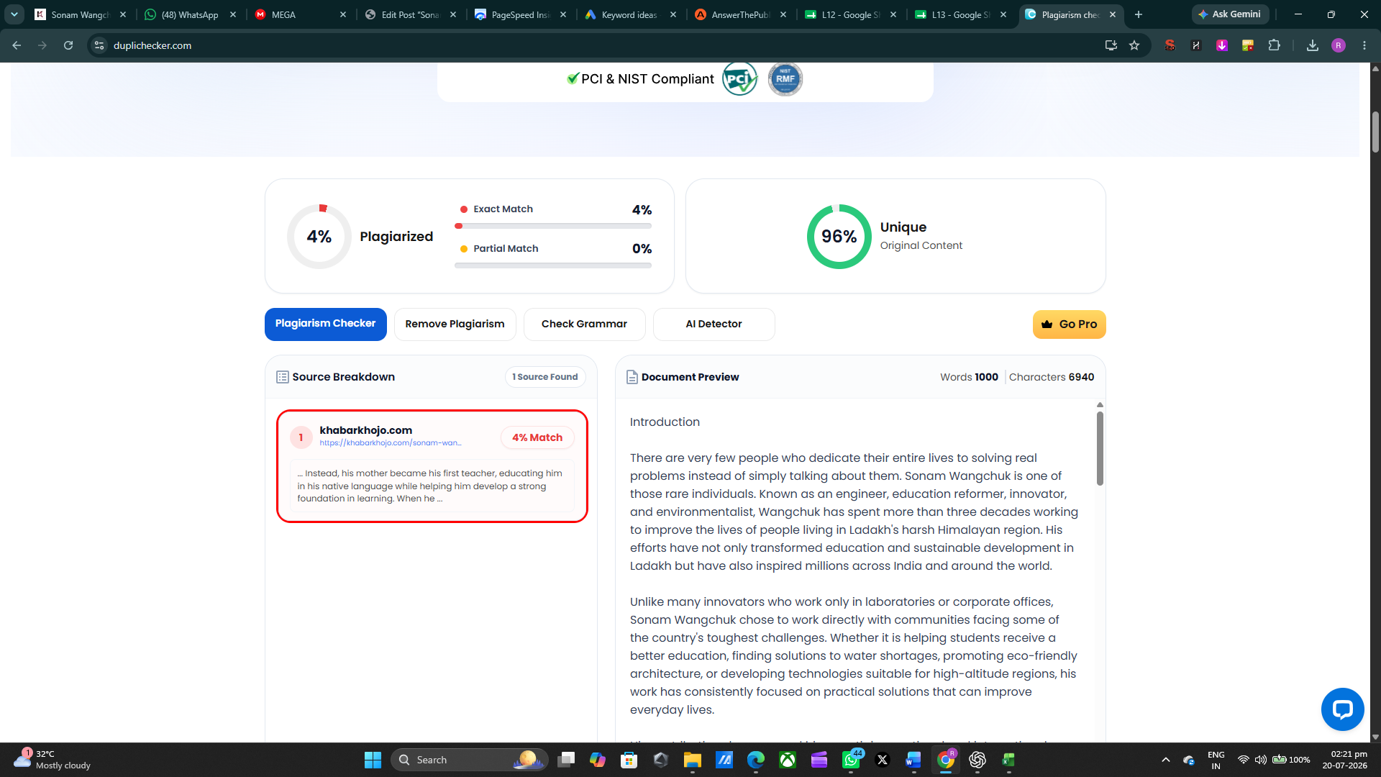
And the blog is live on our website
https://khabarkhojo.com/sonam-wangchuk-dedicated-life-to-india-ladakh/

